

SCHOOL OF COMPUTING AND INFORMATICS

BACHELOR OF SCIENCE IN COMPUTER SCIENCE

UNIT CODE: BIT4138

UNIT NAME: ADVANCED CRYPTOGRAPHY

PROJECT TITLE: SECURE FILE ENCRYPTION SYSTEM

WEEK 1-5 SUMMARY

GITHUB LINK
https://github.com/xoashlyyy/ADVANCED_cryptography

NAME | REG. NO
ASHLEY JOY ONYANGO | BSCCS/2024/50264

LECTURER: Mr. MICHAEL NYORO
SUBMISSION DATE: 08/06/2026

Contents
Week 1: Cryptography Environment Setup 3
Week 2: Classical Cryptography and Cipher Design 5
Week 3: Stream Ciphers and Randomness Testing 9
Week 4: Block Cipher Design and AES 10
Week 5: Public Key Cryptography (RSA) 12
Creative Project: Interactive Crypto Vault Dashboard 13
Week 6 15
Task 1: Basic SPN Design & Implementation 15
Practical Task 2: Non-Linearity Investigation 16
1. What is Non-Linearity in Cryptography? 16
2. Why is Non-Linearity Critically Important? 17
3. How S-Boxes Create Non-Linearity 17
Practical Task 3: SPN vs. Feistel Structure Security Evaluation 17
1. Architectural Comparison 17
2. Evaluation Matrix 18
Task 4: Advanced programming task 19
Task 5: Challenge task 20
Security Analysis Report: Advanced Multi-Round SPN 22

Lit of Figures

Figure 1: Installation of Python and VS Code 4
Figure 2: : Installation of Cryptography Libraries 5
Figure 3: OpenSSL Installation Test 5
Figure 4: Local Encryption Python Script 5
Figure 5: Local Encryption Script Execution 5
Figure 6: GitHub Repository Initialization 6
Figure 7: Caesar Cipher & Vigenère Cipher Python Script 7
Figure 8: Encryption and Decryption Output 8
Figure 9: User Input Validation Python Script 8
Figure 10: User Input Validation Output 9
Figure 11: LFSR Generator Implementation Python Code 10
Figure 12: Pseudorandom Sequence Output 10
Figure 13: Statistical Randomness Testing 11
Figure 14: Encryption Performance Python Code 11
Figure 15: Encryption Performance Results 11
Figure 16: AES Encryption Python Script 11
Figure 17: Key Generation Process 12
Figure 18: Encryption process 12
Figure 19: Decryption Process 12
Figure 20: File Encryption & Decryption Results 12
Figure 21: RSA Key Pair Generation 13
Figure 22: Public Key Encryption Process 13
Figure 23: Private Key Decryption Process 13
Figure 24: Secure Message Transmission 13
Figure 25: Message Decryption 13
Figure 26: Requirements Installation(CP) 14
Figure 27: Interface Architecture 15
Figure 28: Backend Integration 15
Figure 29: Interactive Encryptor 16
Figure 30: S-Box Dictionary Mapping for the Substitution (Confusion) Layer 16
Figure 31: P-Box Logic utilizing Block Reversal for the Permutation (Diffusion) Layer 17
Figure 32: Terminal Output demonstrating the Step-by-Step SPN Encryption Transformation 17
Figure 33: Multi-Round SPN Execution Framework 20
Figure 34: Implementation of Non-Linear Substitution (S-Box) and Linear Permutation Layers 20
Figure 35: Corrected Key Mixing Logic Utilizing Bitwise XOR 20
Figure 36: User Execution Logic and Avalanche Effect Mathematical Calculation 21
Figure 37: Successful Execution of Multi-Round SPN and Avalanche Effect Demonstration 21
Figure 38: Bitwise XOR Key Mixing Implementation 21
Figure 39: S-Box Substitution and Block Reversal Permutation Functions 21
Figure 40: Multi-Round SPN Execution Framework 22
Figure 41: Streamlit Graphical Interface Input Configuration 22
Figure 42: Event Trigger and Avalanche Effect Calculation Logic 22
Figure 43: Streamlit Web Dashboard Demonstrating the Advanced Multi-Round SPN Implementation 22

Week 1: Cryptography Environment Setup
Installation and Configuration of Cryptography Development Environment
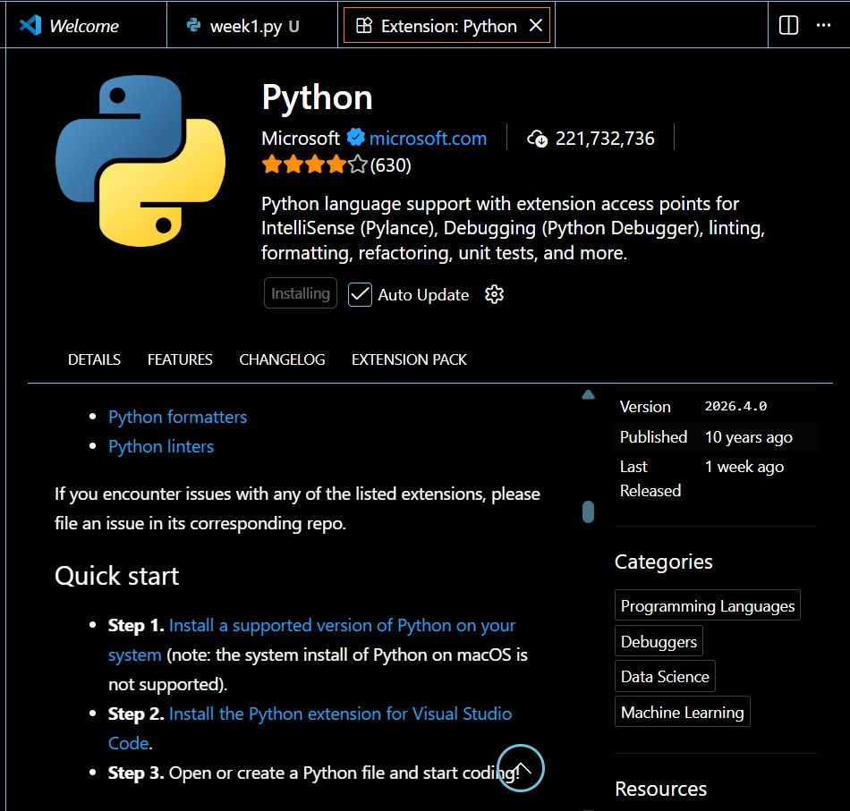
Figure 1: Installation of Python and VS Code
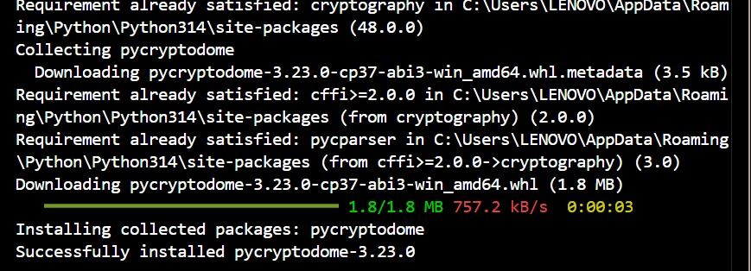
Figure 2: : Installation of Cryptography Libraries
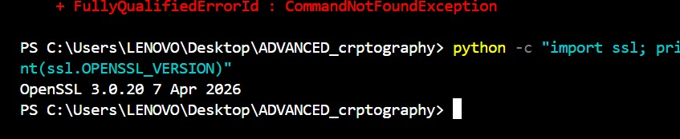
Figure 3: OpenSSL Installation Test
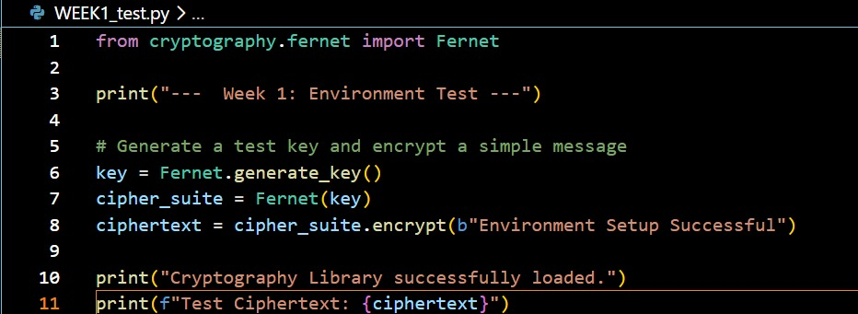
Figure 4: Local Encryption Python Script
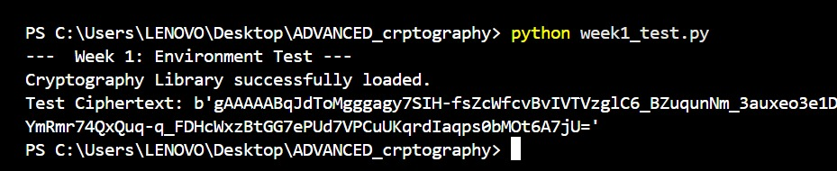
Figure 5: Local Encryption Script Execution
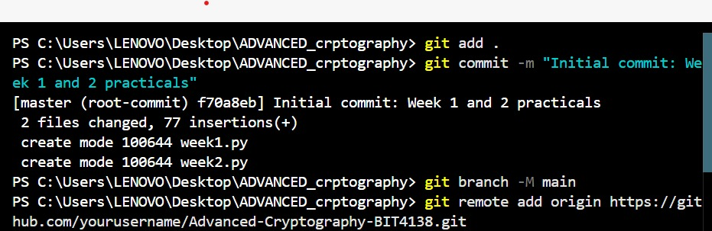
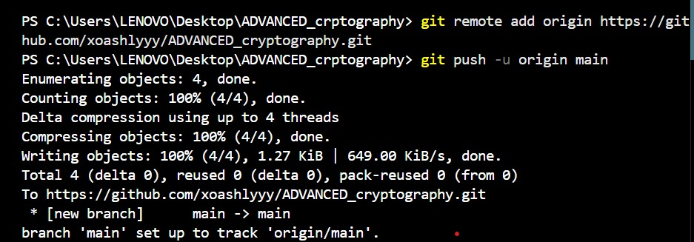
Figure 6: GitHub Repository Initialization

I successfully configured the Python development environment and VS Code for cryptographic operations. OpenSSL was installed for generating secure keys and certificates, and Git was initialized for version control. These tools establish the technical foundation for implementing secure encryption algorithms in subsequent tasks.

Week 2: Classical Cryptography and Cipher Design
Implementation of Classical Encryption Algorithms
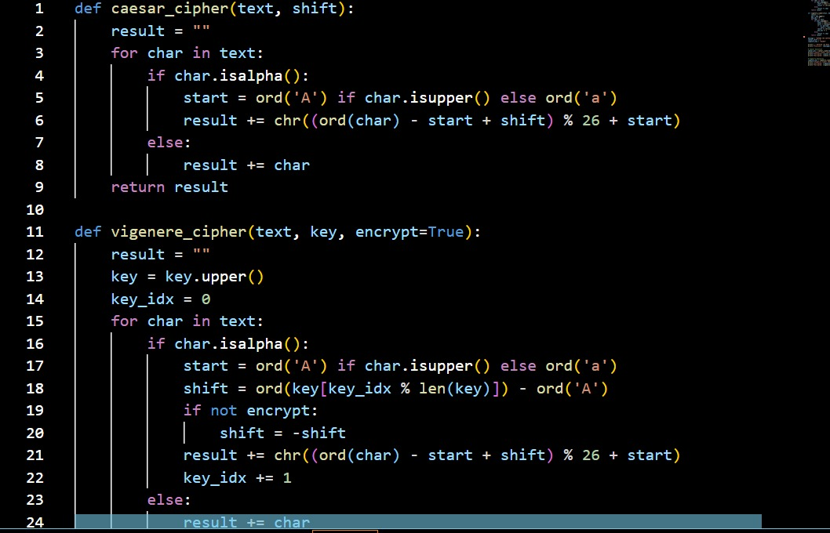
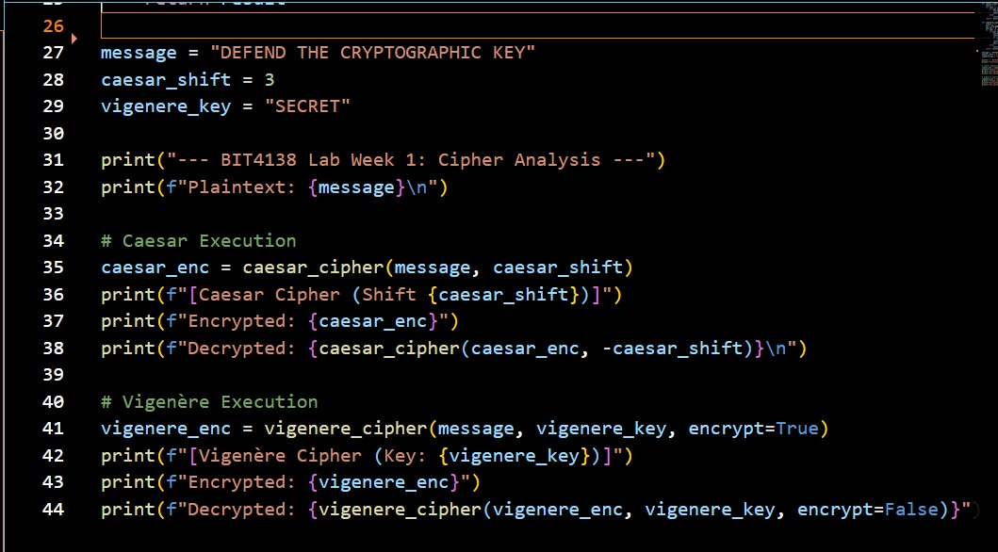
Figure 7: Caesar Cipher & Vigenère Cipher Python Script
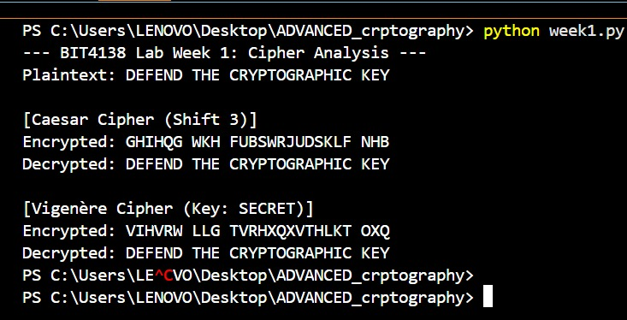
Figure 8: Encryption and Decryption Output

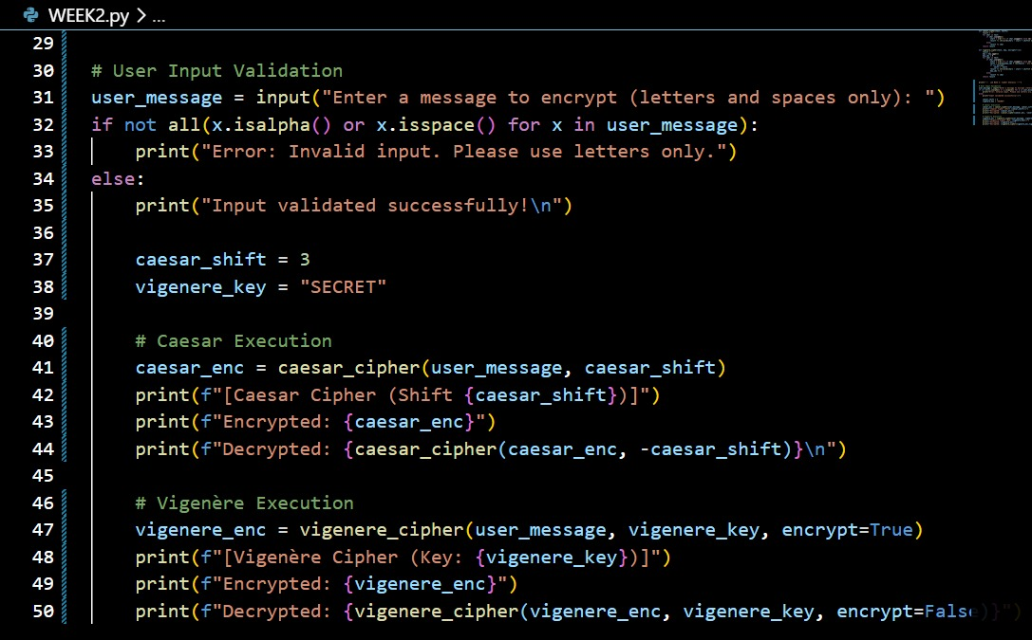
Figure 9: User Input Validation Python Script
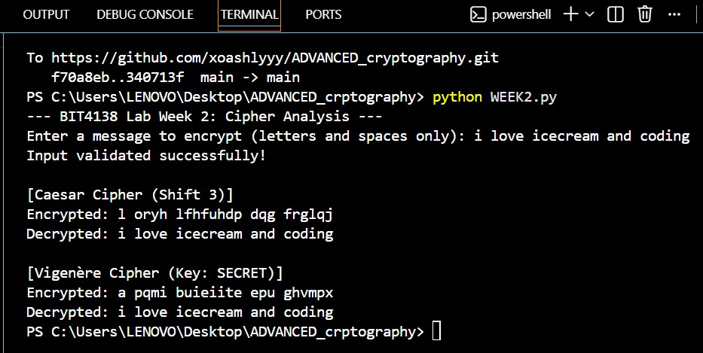
Figure 10: User Input Validation Output
I built interactive Caesar and Vigenere ciphers, testing their encryption workflows. I learned that while Caesar is easily broken due to fixed shifting, Vigenere’s multi-character keys drastically improve security by obscuring character frequencies. The outputs confirm polyalphabetic substitution effectively mitigates the core vulnerabilities of classical monoalphabetic algorithms.

Week 3: Stream Ciphers and Randomness Testing
Implementation of Stream Cipher Systems and Random Sequence Analysis
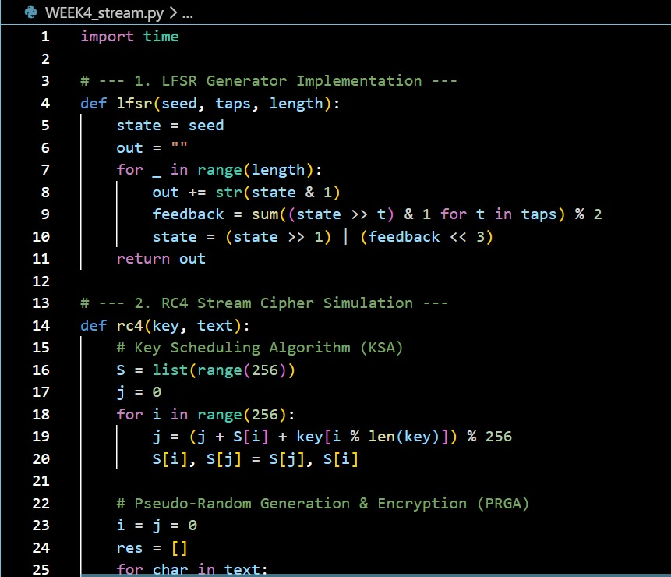
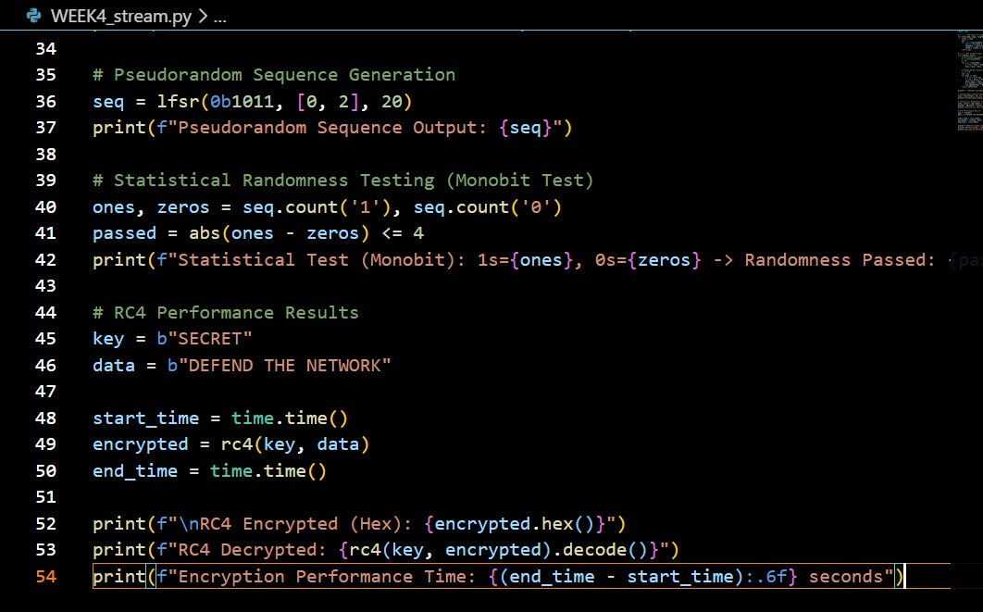
Figure 11: LFSR Generator Implementation Python Code

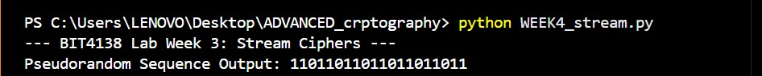
Figure 12: Pseudorandom Sequence Output
Figure 13: Statistical Randomness Testing
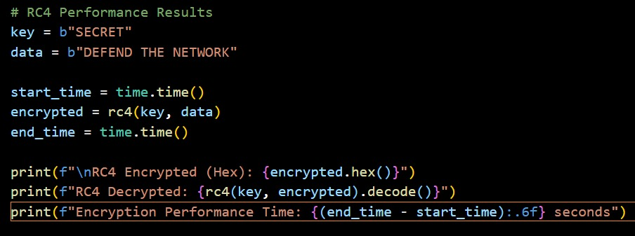
Figure 14: Encryption Performance Python Code
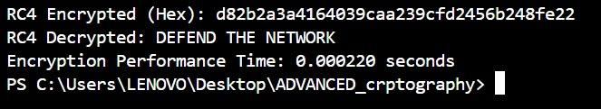
Figure 15: Encryption Performance Results

The RC4 implementation demonstrated real-time stream encryption where data is encrypted bit-by-bit using a keystream. Statistical randomness tests, including frequency analysis, were utilized to evaluate the unpredictability and quality of the generated pseudorandom sequences, ensuring secure cipher operations.

Week 4: Block Cipher Design and AES
Advanced Encryption Standard (AES) and Block Cipher Operations
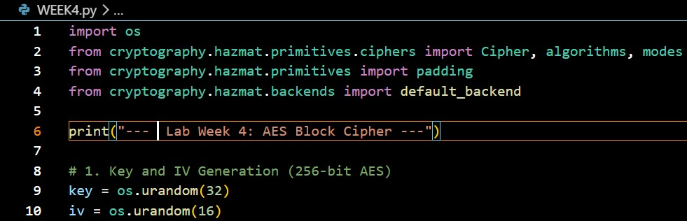
Figure 16: AES Encryption Python Script
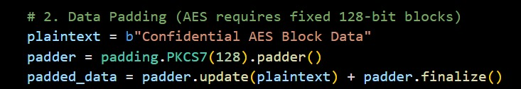
Figure 17: Key Generation Process
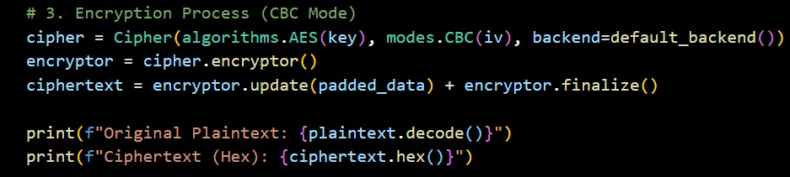
Figure 18: Encryption process
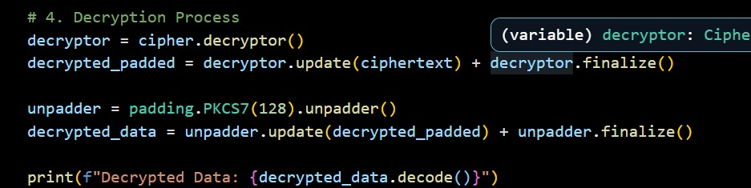
Figure 19: Decryption Process
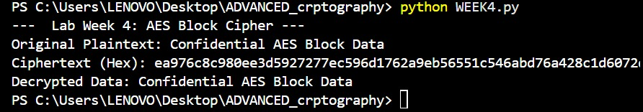
Figure 20: File Encryption & Decryption Results

AES encryption was utilized to securely encrypt text files, emphasizing the importance of symmetric key generation and handling. The implementation highlighted how block ciphers process data in fixed sizes through multiple rounds, successfully demonstrating secure encryption and decryption workflows.

Week 5: Public Key Cryptography (RSA)
Implementation of RSA Encryption and Key Management
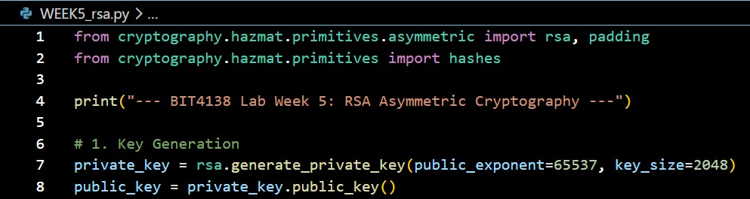
Figure 21: RSA Key Pair Generation
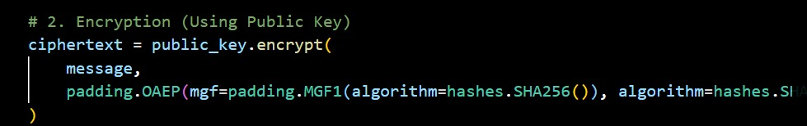
Figure 22: Public Key Encryption Process
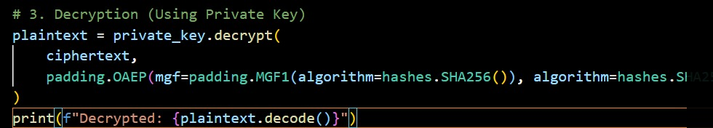
Figure 23: Private Key Decryption Process
Figure 24: Secure Message Transmission
Figure 25: Message Decryption
RSA asymmetric encryption demonstrated secure communication by separating keys into public and private pairs. The implementation highlighted the security advantages of using a public key for message encryption, while successful decryption was restricted strictly to the corresponding private key.

Creative Project: Interactive Crypto Vault Dashboard
1. Environment Setup
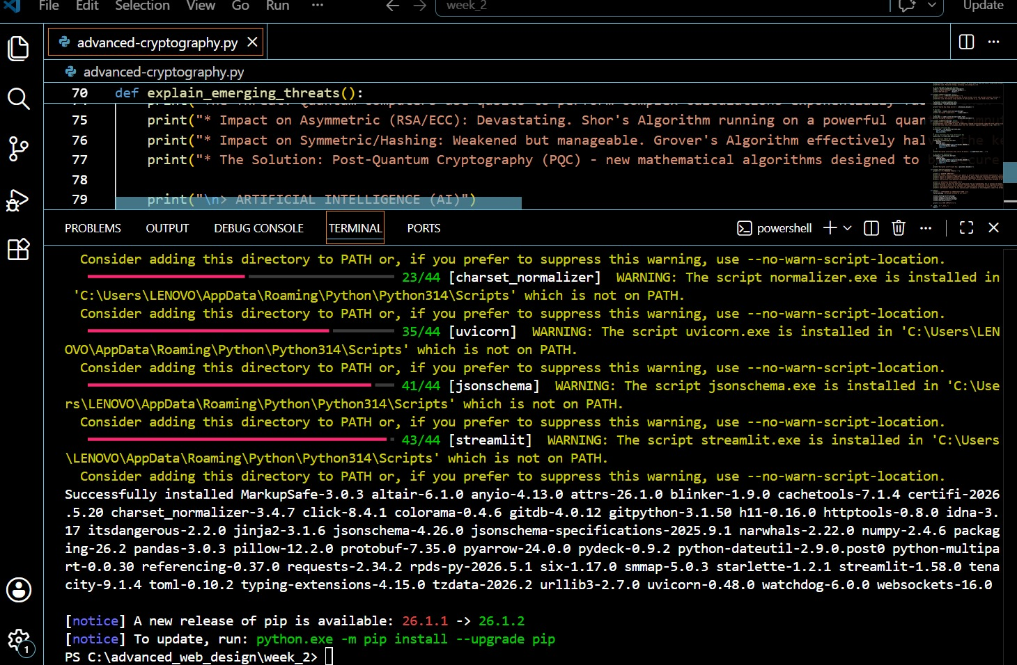
Figure 26: Requirements Installation(CP)

​3. Interface Architecture
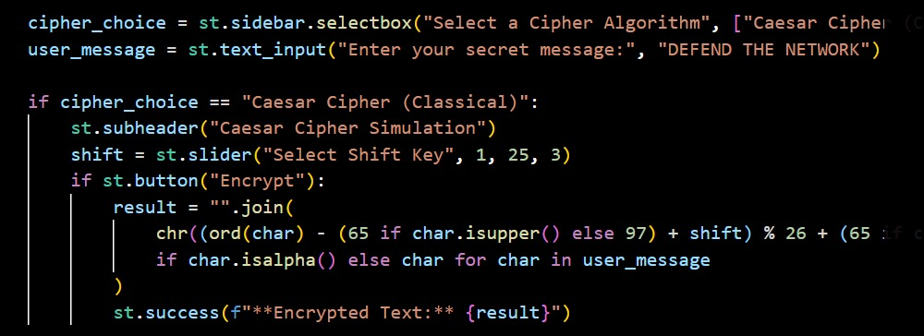
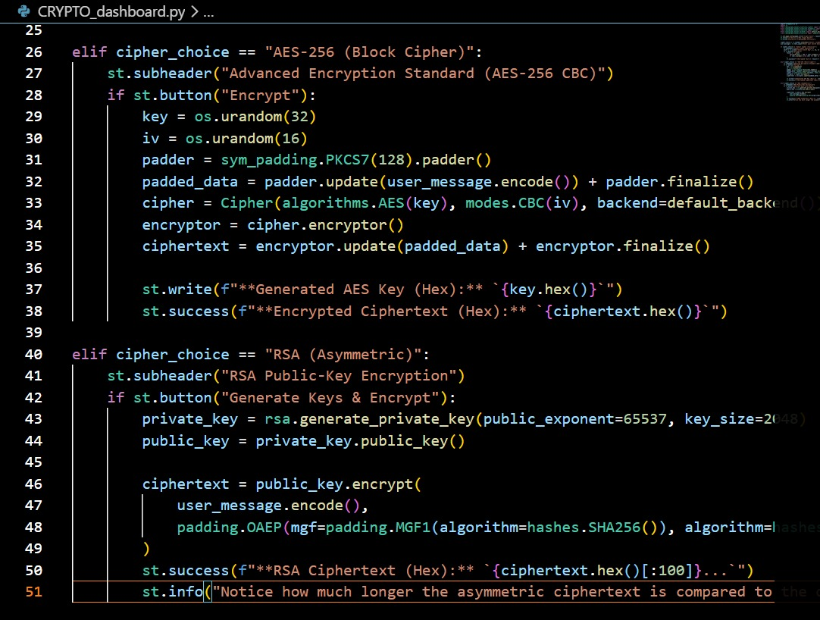
Figure 27: Interface Architecture

​4. Backend Integration
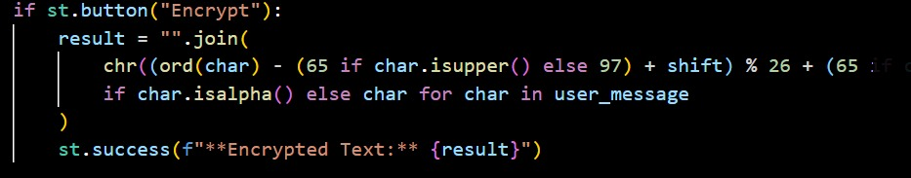
Figure 28: Backend Integration

​5. Input & Event Handling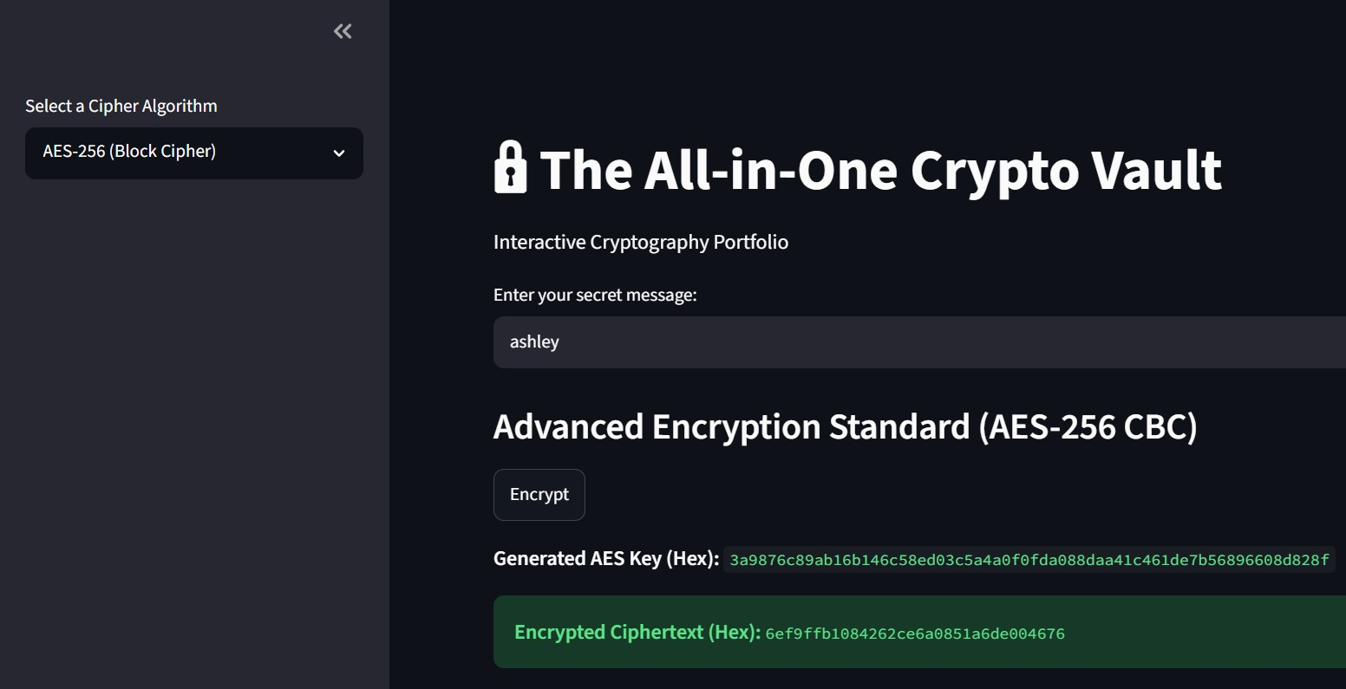
Figure 29: Interactive Encryptor
Building the Interactive Crypto Vault Dashboard using Streamlit successfully bridged complex cryptographic mathematics with an accessible frontend experience. Consolidating standalone cipher scripts into a unified, responsive application allowed for real-time encryption testing. This practical project reinforced how graphical interfaces significantly enhance the usability of advanced security algorithms.
​

Week 6

Task 1: Basic SPN Design & Implementation
​This task involved designing a basic Substitution-Permutation Network (SPN) in Python. The script processes user-entered plaintext through an S-Box mapping layer to achieve confusion, followed by a block-reversal permutation layer to achieve diffusion. The terminal successfully displayed the step-by-step mathematical transformation into secure ciphertext.

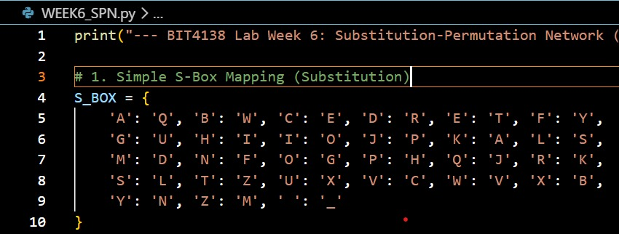
Figure 30: S-Box Dictionary Mapping for the Substitution (Confusion) Layer

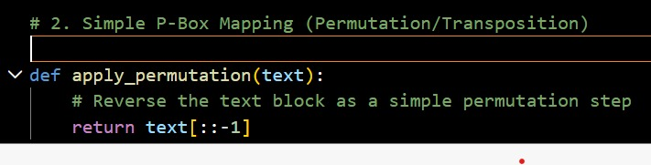
Figure 31: P-Box Logic utilizing Block Reversal for the Permutation (Diffusion) Layer
​

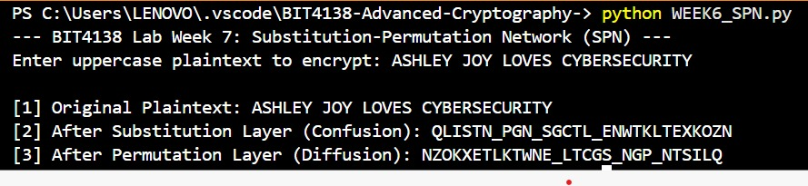
Figure 32: Terminal Output demonstrating the Step-by-Step SPN Encryption Transformation

Practical Task 2: Non-Linearity Investigation

1. What is Non-Linearity in Cryptography?
In symmetric key cryptography, a mathematical function or transformation is defined as linear if it preserves the operation of vector addition and scalar multiplication. In the context of binary fields and bitwise operations, commonly used in block and stream ciphers, a function f is considered linear if it strictly adheres to the principle of superposition:
f(x$⨁$y) = f(x) $⨁$ f(y)
where $⨁$ represents the bitwise Exclusive OR (XOR) operation.

Conversely, a non-linear function is any mathematical transformation that systematically violates this property. For a non-linear function, the relationship between the input bits and the resulting output bits cannot be modeled by a system of linear equations. Mathematically:
f(x$⨁$y) $≠$ f(x) $⨁$ f(y)

In practical block cipher architectures like the Substitution-Permutation Network (SPN), ciphers are divided into layers. The key addition layer and the permutation layer (which shifts or transposes bits) are entirely linear. The non-linear component must be deliberately introduced elsewhere, typically through a localized lookup structure known as a Substitution Box (S-Box).

2. Why is Non-Linearity Critically Important?
Non-linearity forms the core defensive barrier that guarantees the security of a modern cipher. Without a non-linear component, an entire multi-round cryptographic algorithm collapses mathematically into a single, trivial system of linear relationships.

The Vulnerability of Pure Linearity
If a cipher consisted only of linear layers (such as Key Addition and Permutations), an attacker could combine multiple rounds together. Because the composition of any two linear functions is always another linear function, a 10-round or 100-round linear cipher would have the exact same algebraic strength as a 1-round cipher.

Defeating Linear Cryptanalysis
In 1993, researcher Mitsuru Matsui introduced Linear Cryptanalysis, an attack vector that seeks to find high-probability linear approximations of a cipher's internal operations. If an attacker can find a linear path through a cipher, they can record a sufficient number of plaintext-ciphertext pairs and use basic matrix algebra (such as Gaussian elimination) to solve for the secret round keys.
Non-linearity prevents this by breaking the predictable propagation of bit changes, ensuring that any linear approximation holds a probability as close to 0.5 (pure randomness) as possible.

3. How S-Boxes Create Non-Linearity
S-Boxes achieve non-linearity by functioning as localized, highly complex algebraic functions wrapped into fixed lookup tables. Instead of scaling or shifting bits uniformly, modern S-Boxes rely on advanced field mathematics.

Galois Field Inversion (GF($2^{n}$))
In advanced ciphers like the Advanced Encryption Standard (AES), the 8-bit S-Box is designed using the multiplicative inverse over the finite mathematical field GF($2^{8}$), combined with an affine transformation.
Because finding a multiplicative inverse ($x^{-1}$ mod P(x)) is a highly non-linear operation, it yields maximum resistance against both linear and differential cryptanalysis. If an input changes by only a single bit, the non-linear properties of the S-Box cause roughly half of the output bits to flip unpredictably, creating the structural phenomenon known as the Avalanche Effect.

Practical Task 3: SPN vs. Feistel Structure Security Evaluation

1. Architectural Comparison
Modern block ciphers generally utilize one of two primary architectural frameworks to process plaintext into ciphertext: the Substitution-Permutation Network (SPN) or the Feistel Structure.
Substitution-Permutation Network (SPN): This architecture applies mathematical transformations to the entire data block simultaneously during each round. It uses parallel substitution boxes (S-Boxes) to create confusion and permutation boxes (P-Boxes) to create diffusion.
Feistel Structure: This architecture splits the data block into two equal halves (Left and Right). During each encryption round, a non-linear "round function" is applied to the right half using a subkey, and the result is XORed with the left half. The halves are then swapped for the next round. Consequently, only half of the data block is mathematically altered per round.

2. Evaluation Matrix

A. Security
SPN Structure: Highly secure per round. Because the S-Boxes and P-Boxes operate on the entire data block at once, SPN achieves complete diffusion very rapidly (often in just 1 to 2 rounds). However, the security is entirely dependent on the mathematical strength of the S-Boxes; a poorly designed S-Box compromises the entire cipher.

Feistel Structure: Inherently robust design. A unique security advantage of the Feistel network is that the internal round function F does not need to be mathematically invertible (reversible) for the cipher to work. However, because only half the block is encrypted per round, it requires significantly more rounds to achieve the same level of diffusion as an SPN.

B. Performance
SPN Structure: Highly performant, especially in hardware implementations. Because SPN applies its S-Box transformations in parallel across the entire block, it is heavily optimized for modern multi-core processors. It generally requires fewer rounds (e.g., AES uses 10 to 14 rounds) to achieve maximum security, leading to faster encryption and decryption speeds.

Feistel Structure: Slower by comparison. The alternating nature of the left-right block swap limits parallel processing capabilities. Furthermore, to achieve a secure avalanche effect, a Feistel cipher usually requires a higher round count (e.g., DES uses 16 rounds) since only 50% of the bits are manipulated per cycle.

C. Ease of Implementation
SPN Structure: More complex to implement. To decrypt an SPN cipher, the software must contain entirely separate logic blocks. The programmer must design and integrate inverse S-Boxes (reverse lookup tables) and inverse P-Boxes, effectively requiring two distinct algorithms for encryption and decryption.

Feistel Structure: Exceptionally easy to implement. The greatest engineering advantage of a Feistel network is that the encryption and decryption processes use the exact same algorithmic code. To decrypt a message, the system simply runs the ciphertext through the identical encryption function, but feeds the round keys in reverse order.

D. Modern Usage
SPN Structure: This is the dominant architecture in modern cryptography. It is the underlying framework for the Advanced Encryption Standard (AES), which is the current global standard utilized by governments, financial institutions, and secure web protocols (HTTPS/TLS).
Feistel Structure: While historically significant, it is largely considered a legacy architecture. It was the foundation for the Data Encryption Standard (DES), Triple DES (3DES), and Blowfish. While variations of it are still used in some modern ciphers (like Camellia), SPN has largely replaced it for high-performance data protection.

Task 4: Advanced programming task
​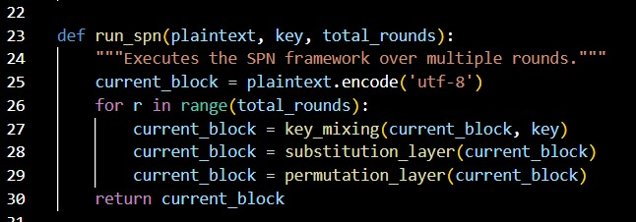
Figure 33: Multi-Round SPN Execution Framework
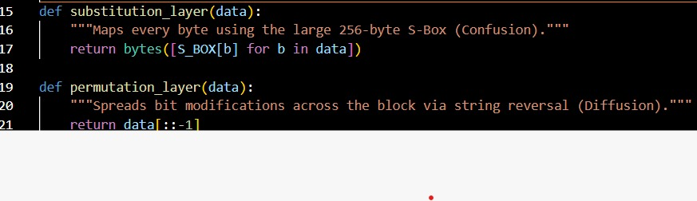
Figure 34: Implementation of Non-Linear Substitution (S-Box) and Linear Permutation Layers
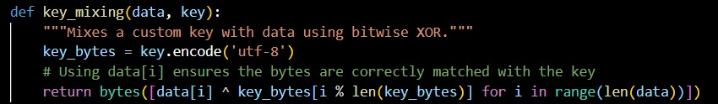
Figure 35: Corrected Key Mixing Logic Utilizing Bitwise XOR

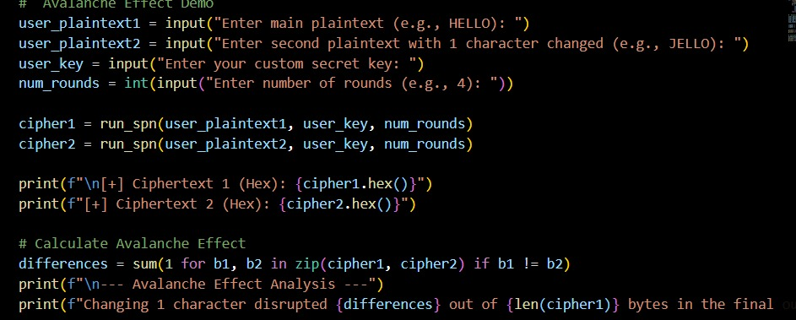
Figure 36: User Execution Logic and Avalanche Effect Mathematical Calculation 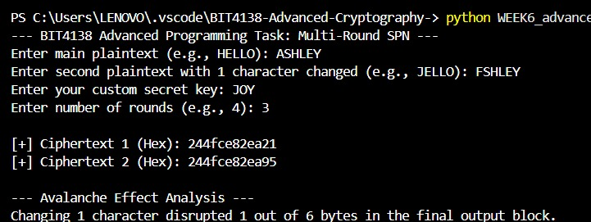
Figure 37: Successful Execution of Multi-Round SPN and Avalanche Effect Demonstration

Task 5: Challenge task
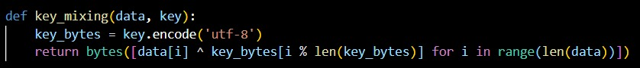
Figure 38: Bitwise XOR Key Mixing Implementation
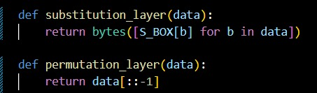
Figure 39: S-Box Substitution and Block Reversal Permutation Functions

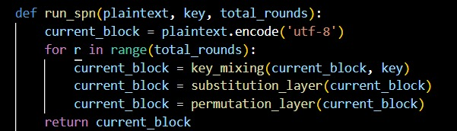
Figure 40: Multi-Round SPN Execution Framework
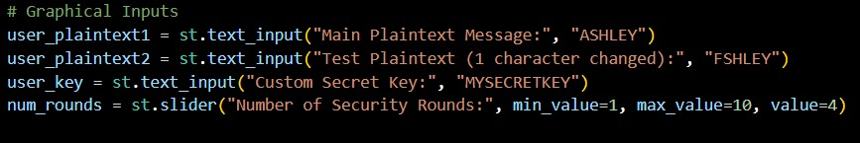
Figure 41: Streamlit Graphical Interface Input Configuration
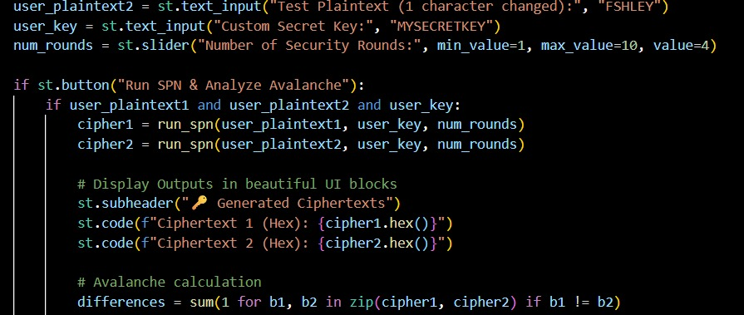
Figure 42: Event Trigger and Avalanche Effect Calculation Logic
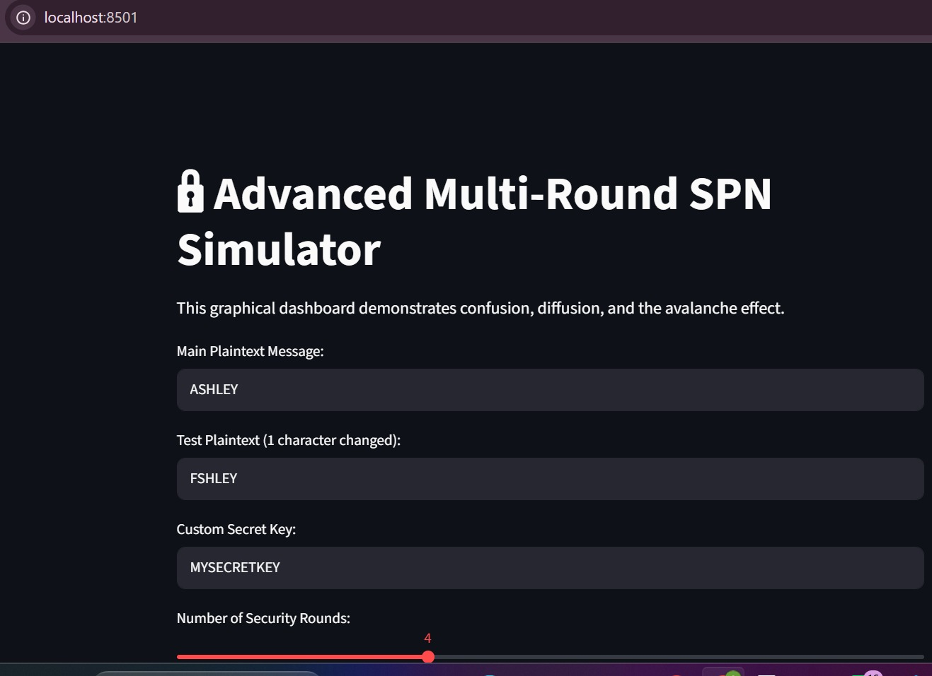
Figure 43: Streamlit Web Dashboard Demonstrating the Advanced Multi-Round SPN Implementation

Security Analysis Report: Advanced Multi-Round SPN

1. Architectural Design Overview
This project upgrades a basic Substitution-Permutation Network (SPN) into a much stronger, multi-round cryptographic simulator. Instead of just processing the data once, the cipher loops the plaintext through multiple encryption cycles (for example, 4 rounds). This repetitive compounding drastically increases the scrambling effect, making the cipher incredibly resistant to statistical cryptanalysis.

2. Component Security Analysis
i) Custom Key Mixing: At the start of the encryption loop, the system mixes in a custom secret key (like MYSECRETKEY) using a bitwise XOR operation. This ensures the final ciphertext is mathematically locked to the user's password. It directly applies Kerckhoffs's Principle, even if an attacker knows exactly how our algorithm works, the data remains totally secure without that exact key.

ii) Enhanced Substitution Layer (Confusion): Upgrading to a massive 256-byte randomized S-Box introduces intense non-linearity. Rather than just shifting letters like a basic classical cipher, this lookup table completely destroys any predictable algebraic relationship between the plaintext and ciphertext. It creates deep "confusion" to neutralize linear cryptanalysis attacks.

iii) Permutation Layer (Diffusion): The block-level permutation mechanism shifts the bytes around to guarantee that localized data changes are spread across the entire block. This satisfies Claude Shannon’s property of "diffusion," ensuring that individual byte patterns disappear entirely into the final output.

3. Avalanche Effect Verification
The most effective way to prove the cipher's structural integrity is by visually simulating the Avalanche Effect. As demonstrated in the dashboard, altering just one single character in the plaintext, such as modifying "ASHLEY" to "FSHLEY", triggers a massive mathematical disruption. Because of the multi-round confusion and diffusion layers compounding on top of each other, that tiny input tweak drastically changes the final hexadecimal output. This divergence confirms that the simulator successfully masks input modifications and can defend against differential cryptanalysis.

